1. Long-stemmed pea plants were crossed with short-stemmed pea plants. All the offspring

were long-stemmed plants

The genotypes of the offspring plants are:

* 1. either homozygous dominant or heterozygous
  2. heterozygous only
  3. homozygous dominant only
  4. homozygous recessive only

1. Recombination occurs during:
   1. anaphase of the second meiotic division, as chromosomes separate
   2. metaphase of the first meiotic division, as chromosomes are paired
   3. interphase as chromosomes are replicated
   4. telophase of the first meiotic division, when cytoplasm is divided into two parts
2. Which of the following is NOT a significant source of variation in humans?
   1. Random fertilization
   2. DNA replication
   3. Recombination
   4. Non-identical parents
3. Fragile-X syndrome is caused by a single gene defect of the FMR1 gene on the X chromosome, causing mental retardation.

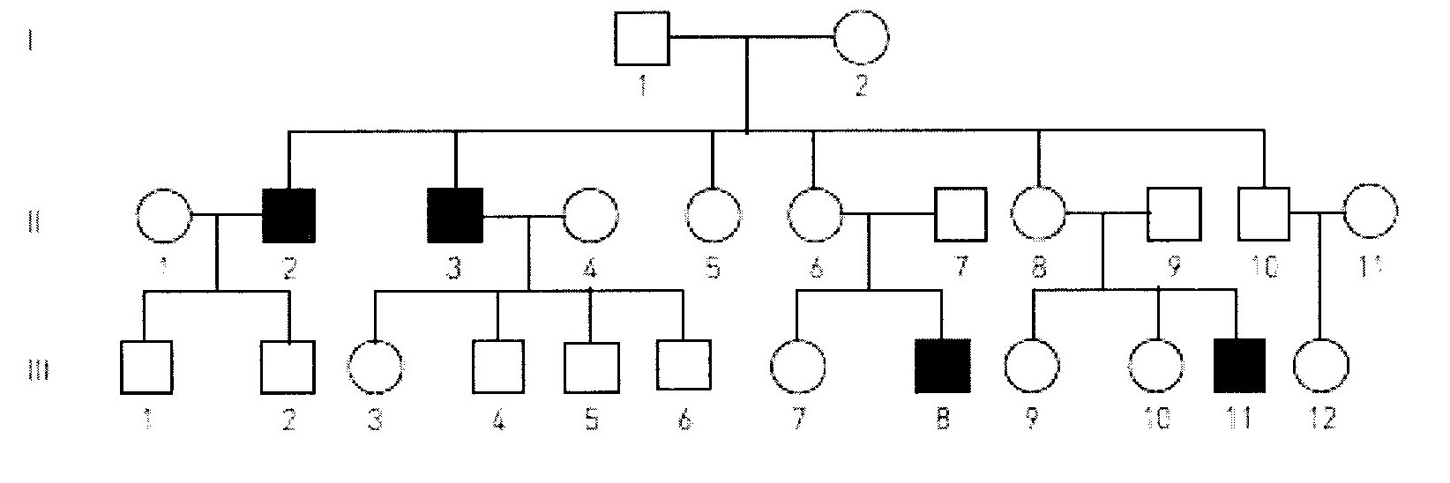

Using the pedigree shown, which one of the following combinations of genotypes is possible for the individuals listed?

* 1. I 2: XF Xf, II 4: XF Xf, III 6: XF Y
  2. I 2: XF Xf, II 4: XF XF, III 6: Xf Y
  3. I 2: XF XF, II 4: XF XF, III 6: XF Y
  4. I 2: Xf Xf II 4: XF Xf, III 6: Xf Y

1. In regards to sex determination, which statement is correct?
   1. A zygote with X and Y chromosomes will develop into a female.
   2. Two X chromosome ova can fuse to develop into a female with XX chromosomes.
   3. Half of all ova have X chromosomes, while the other half have Y chromosomes.
   4. Half of all sperm have X chromosomes, while the other half have Y chromosomes.
2. A haemophiliac man and a non-haemophiliac woman, who comes from a family with no history of haemophilia, have a daughter.

Which probability matches this circumstance?

* 1. There is a 50% chance the daughter has haemophilia
  2. There is a 100% chance the daughter is a carrier
  3. There is a 50% chance the daughter is homozygous dominant
  4. There is a 100% chance the daughter is homozygous recessive.

1. Non-disjunction producing non-haploid gametes can occur during:
   1. the first or second meiotic division.
   2. The first meiotic division only.
   3. the second meiotic division only
   4. mitotic division
2. Fertilization by any particular sperm is:
   1. irrelevant because they will all have identical chromosomes.
   2. dependant on chromosomes matching
   3. controlled by the ovum
   4. random.
3. Fragile-X syndrome is caused by a single gene defect of the FMR1 gene on the X chromosome causing mental retardation.



From the pedigree above, what is the probability that individual II 5 is a carrier of Fragile-X syndrome?

a. 0

b. 1

c. ½

d. ¼

1. One type of colour blindness is determined by a gene on the X chromosome.

Which of the following lists all the possible genotypes that could result from a cross between individuals with the genotypes Xb Y and XB Xb?

a. XB Y, Xb Y, XB XB, XB Xb

b. XB Y, Xb Y, XB XB

c. XB Yb, XbY, XB Xb, XB XB

d. XB Y, Xb Y, XB Xb, Xb Xb

1. Two parents who are not albino have one child that is albino. The probability that a second child would be albino is:

a. 25%

b. 50%

c. 0%

d. 100%

1. A father with blood type A and a mother with blood type O have children.

The blood types of these children may be:

a. A

b. O

c. A or O

d. A or B

**SHORT ANSWER**

Write the correct term for the meanings written in the table below.

|  |  |  |
| --- | --- | --- |
| **No.** | **MEANING** | **TERMINOLOGY** |
| 1 | Produce the same characteristic in succeeding generations when bred among themselves |  |
| 2 | the mating of two organisms – in genetics |  |
| 3 | the situation where an individual has the same allele for a particular characteristic |  |
| 4 | gel electrophoresis is used to make a genetic…. |  |
| 5 | A male gets his Y chromosome from his…? |  |
| 6 | Huntington’s disease shows this type of inheritance… |  |
| 7 | Differences between members of a species are called… |  |
| 8 | Surname of a British geneticist who devised a square to help with his work on heredity. |  |
| 9 | A non-sex chromosome |  |
| 10 | Where a person has only one copy of a chromosome, where normally there would be two |  |

11. This diagram represents changes in the numbers of chromosomes during reproduction and growth.

Parents 2n 2n

(x)

Gametes

n n

Zygote (y)

2n

(z)

2n

a. What does 2n represent? __________________________________________________

b. What does n represent? __________________________________________________

c. Identify the process: (x) ____________________________________________________

(y) ____________________________________________________

(z) ____________________________________________________

12. A woman of blood group A claims that a man of blood group AB is the father of her child. A blood test reveals that the child’s blood group is O.

a. Is it possible the woman’s claim is correct? Show working

b. Could the father of the child have been a group B man? Explain your reasoning.

_____________________________________________________________________________

_____________________________________________________________________________

13. A woman is heterozygous for a sex-linked recessive characteristic. She has children with a man who has the characteristic. What will be the proportion of the genotypes and phenotypes in their offspring?

Show all working

**SECTION C – EXTENDED RESPONSE**

14. a. Describe three inheritance processes which introduce variation into a species. (15 marks)

__________________________________________________________________________________________________________________________________________________________________________________________________________________________________________________________________________________________________________________________________________________________________________________________________________________________________________________________________________________________________________________________________________________________________________________________________________________________________________________________________________________________________________________________________________________________________________________________________________________________________________________________________________________________________________________________________________________________________________________________________________________________________________________________________________________________________________________________________________________________________________________________________________________________________________________________________________________________________________________________________________________________________________________________________________________________________________________________________________________________________________________________________________________________________________________________________________________________________________________________________________________________________________________________________________________________________________________________________________________________________________________________________________________________________________________________________________________________________________________________________________________________________________________________________________________________________________________________________________________________________________________________________________________________________________________________________________________________________________________________________________________________________________________________________________________________________________________________________________________________________________________________________________________________________________________________________________________________________________________________________________________________________________________________________________________________________________________________________________________________________________________________________________________________________________________________________________________________________________________________________________________________________